
RAMAIAH
Institute of Technology
USN | 1 | M | S

(Autonomous Institute, Affiliated to VTU)
(Approved by AICTE, New Delhi & Govt. of Karnataka) Accredited by NBA & NAAC with ‘A’ Grade

MAKEUP EXAMINATIONS – FEBRUARY 2019

Course & Branch | : | B.E: Electrical and Electronics Engineering | Semester | : | V
Subject | : | Linear Integrated Circuits | Max. Marks | : | 100
Subject Code | : | EE54 | Duration | : | 3 Hrs

Instructions to the Candidates:
- Answer one full question from each unit.

 |  | UNIT- I
1. | a) | Calculate the minimum input impedance and typical output impedance of a 741 operational amplifier employed as a voltage follower.  (From 741 data sheet: minimum open loop gain = 50,000 and typical open loop gain = 2,00,000; minimum open loop input  impedance = 0.3 MΩ; open loop output impedance = 75Ω) | CO2 | (05)
 | b) | The circuit in fig. 1(b) uses a 741 operational amplifier and has R₁ = R₂ = 39KΩ with a resistor tolerance of + 5%. Determine:  - The maximum input offset voltage due to 741 op-amp input offset current.  - The resistor tolerance (From 741 data sheet input offset current = 200 nA; Bias current = 500 nA)  Fig. 1(b) | CO1 | (05)
 | c) | A 1KΩ load is to have 2V developed across it from a 15V source. Design  - A potential divider circuit such that V_{L} is derived directly from V_{CC}(Fig 1. (c)(i)).  - A voltage follower is connected between the potential divider and R_{L}(fig. 1. (c)(ii)).  Calculate load voltage variation in each case, when the load resistance varies by -10%. Use a 741 Op-Amp.  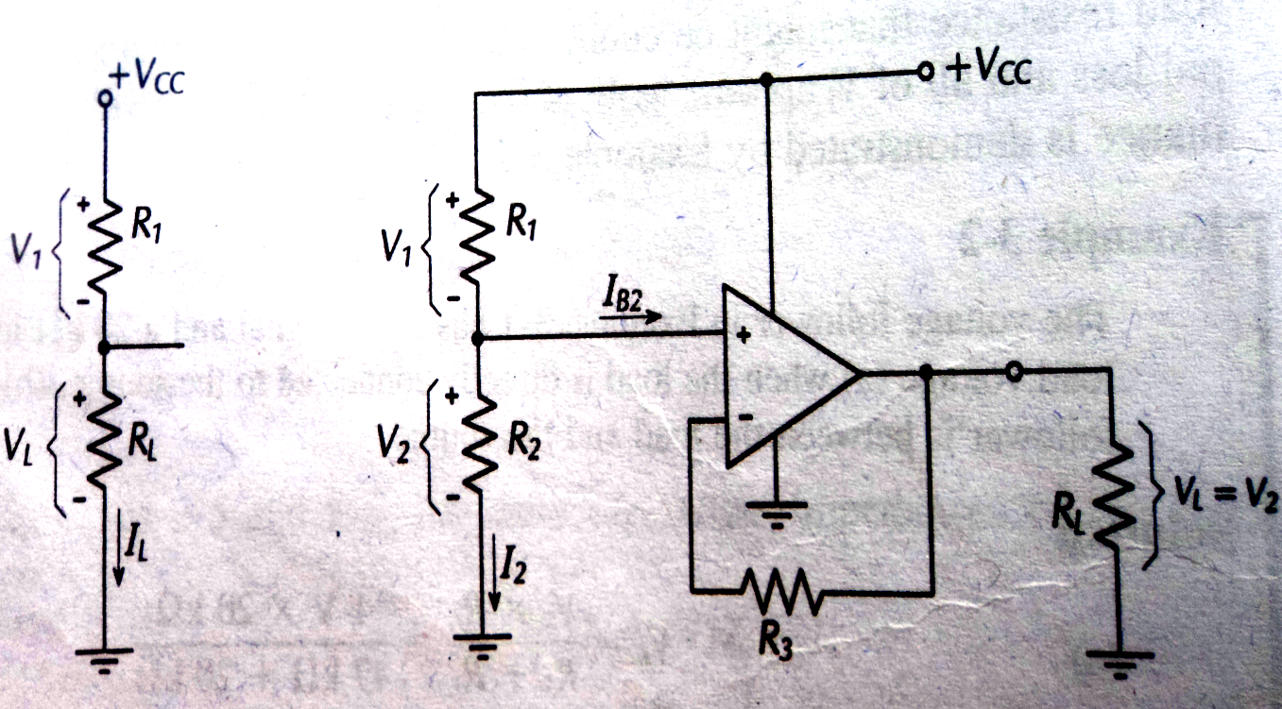  Fig. 1.(c)(i) Fig. 1.(c)(ii) | CO2 | (10)
2. | a) | With a neat sketch explain the working of a differential amplifier. Derive an equation for its output voltage. Discuss the design steps involved in designing the differential amplifier such that the circuit gives approximately same input resistance at the two input terminal and provide output voltage nulling. Also show how output DC voltage level shifting can be provided for differential amplifiers. | CO2 | (10)
 | b) | A direct coupled inverting amplifier with a + 15V supply is to produce maximum possible output voltage and is to have a voltage gain of 40dB. The amplitude of the input voltage is to be 50 mV AC. Using 741 Op-Amp, design a suitable circuit. Ensure that the circuit is suitably compensated for I_{B}R_{B} drop. Draw the circuit diagram with the component values mentioned on it. Also calculate the input and the output impedance for the circuit designed (From 741 data sheet: typical open loop gain = 200000; typical open loop input impedance = 2 MΩ; typical open loop output impedance = 75Ω). | CO2 | (10)
 |  | UNIT- II
3. | a) | The capacitor coupled non-inverting amplifier given in fig. 3(a) has the following component: R₁ = R₂ = 180 KΩ, R₃ = 100 KΩ, R₄ = 10 KΩ, C₁ = 0.047µF, C₂ = 0.47µF, C₃ = 0.047µF and C_{F} = 100 pF. Calculate: (i) the single polarity supply voltage (ii) lower and upper cutoff frequency (iii) the impedance of capacitors C₁, C₂, C₃ and C_{f}, (iv) voltage gain of the circuit (iv) the peak value of input and output voltage (v) the minimum value of load resistance that has to be connected to the output of the circuit.  Draw input waveform V_{in}, output waveform V₀, output of the op-amp waveform V₀¹ with C₃ connected and with C₃ short circuited. (refer circuit diagram)  Fig. 3(a) | CO2 | (15)
 | b) | Discuss the advantages of a precision rectifier over an ordinary diode rectifier circuit. | CO2 | (05)
4. | a) | The circuit shown in fig. 4(a) is a high input impedance precision full wave rectifier. The values of all the resistors are given below:  Resistors R₁=680Ω, R₂ = 470Ω, R₆ = R₅ = R₄ = 1 K and R₃ = 1K + 1 K ohms in series. Calculate the input and output voltage and draw its waveforms along with voltage waveforms at points A, B and C to scale on the graph sheet. Also plot the output waveform on the graph sheet to scale when R₃ = 3.9 KΩ.  Fig. 4(a) | CO2 | (08)
 | b) | A capacitor coupled voltage follower using a 741 op-amp is to have an input impedance of 12 KΩ. The lower cutoff frequency is to be a maximum of 100 Hz and the load resistance can vary from 3.3 KΩ to 15 KΩ. Design a suitable circuit. Draw the circuit with component values mentioned on it. | CO2 | (06)
 | c) | With a neat sketch show how non saturating precision half wave rectifier can be modified to obtain two independent half-wave rectified output. Draw the waveform and explain the circuit operation. | CO2 | (06)
 |  | UNIT- III
5. | a) | A + 5V, 10 KHz square wave from a signal source with a resistance of 100 Ω is to have its positive peak clamped precisely at ground level. Tilt on the output is not to exceed 1% of the peak amplitude of the wave. Design a suitable op-amp circuit using a supply of + 12V.Draw the circuit diagram with component values mentioned on it. | CO2 | (10)
 | b) | Show how two op-amp dead zone circuits can be combined with a summing circuit to produce precision limiting on both positive and negative half cycles of the output waveform. Draw the voltage waveforms throughout the circuit and explain its operation. Discuss the design procedure with equations for determining the value of each component. | CO2 | (10)
6. | a) | With a neat sketch and waveform, explain the working of square wave generator. Derive an expression for its frequency of oscillation. Also list out the steps for designing a square wave generator. | CO2 | (08)
 | b) | Design a Wien bridge oscillator for an oscillating frequency of 3 kHz. Draw the circuit with component values mentioned on it. If the circuit has to oscillate for 3.3 KHz instead of 3 KHz what modification do you suggest? | CO2 | (07)
 | c) | Draw the frequency response plot for different types of active filter. | CO2 | (05)
 |  | UNIT- IV
7. | a) | Design a non-inverting voltage level detector to have V_{UT} = 3 and V_{LT} = 1V. Assume that + V_{sat} = + 15V. Draw the circuit diagram with component values mentioned on it. Draw the expected input and output waveform for the circuit designed. Also draw the hysteresis curve. | CO2 | (10)
 | b) | Sketch a circuit to show Zin mod method of frequency compensation and explain its operation. State the application of the circuit and write equation for the feedback factor. | CO3 | (10)
8. | a) | With a neat sketch and waveforms demonstrate the effect of noise on a open loop zero crossing detector. Suggest the method to reduce the impact of noise on the output voltage of ZCD. | CO2 | (10)
 | b) | Using a 709 Op-amp, design an inverting amplifier as shown in Fig. 8(b) to have A_{V} =1000 and V_{s} =5mV (I_{B(max)} for 709=200nA) and also calculate the input stray capacitance that might make the circuit unstable when:  i) the signal source is open circuited.  ii) R₃ is short circuited  iii) R₃ is present and all resistors are reduced by a factor of 5.  Fig. 8(b) | CO3 | (10)
 |  | UNIT- V
9. | a) | - Design a differentiator to differentiate an input signal that varies in frequency from 10 Hz to 900Hz. Draw the circuit diagram with component values mentioned it.  - If the sine wave input of 1V peak value at 900Hz is applied to the differentiator designed in part (i), calculate its output voltage and plot its input and output waveform. | CO2 | (10)
 | b) | With a neat sketch explain the working of voltage-to-current converter with floating load. Derive an expression for the output current. Bring out the applications of voltage-to-current converter with floating load. | CO4 | (10)
10. | a) | Briefly explain the following terms with respect to voltage regulators:  i) Dropout voltage ii) Temperature stability iii) Ripple rejection. | CO5 | (06)
 | b) | Design an astable multivibrator for a duty cycle of 50%. The free running frequency is 5 kHz. Draw the circuit with component values mentioned on it. | CO5 | (08)
 | c) | With a neat sketch explain the working of astable multivibrator used as a square wave oscillator. | CO5 | (06)
****************

